2.1 User Interface/application states

2.1.1 Launch Page

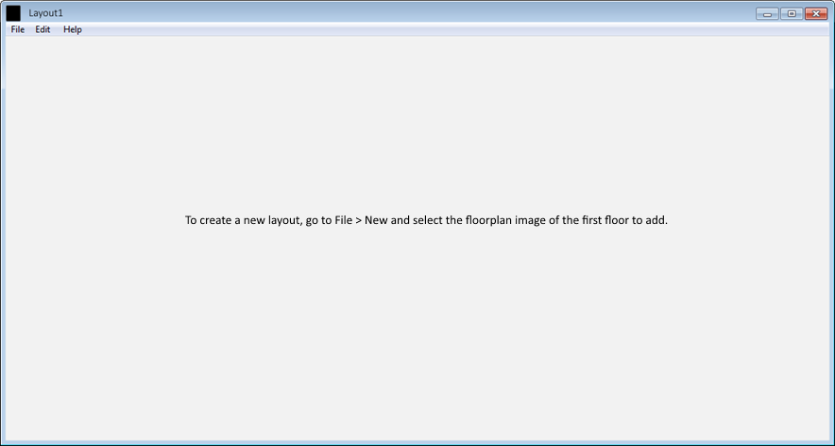

The Launch Page consists of a blank page, only showing the menu bar above the blank space.

The menu bar consists of the following elements;

* File
  + New Project – Initiate a new project, and transition to the **General Editing** state (albeit with a layout with no floors or nodes). The user is queried to select the background of the first floor; after selection, the view appears as it does in the General Editing state.
  + Open Project – Open a previously saved project file to resume progress on creating the layout, before transitioning to the **General Editing** state with the project loaded.
  + Save Project – Save progress in a file that can be later be loaded by either this application, for further editing, or the smartphone application. If file has not yet been saved, clicking ‘Save Project’ is functionally identical to ‘Save Project As…’. Clicking this saves all progress and compresses the work directory (see section 1.1.3) into a ZIP file, with file extension changed to ‘.lay’ (to aid with the smartphone application recognizing files later).
  + Save Project As… - Ditto, but specifying name & location.
  + Exit – Close program.
* Edit
  + Add Floor
    - Above Current Floor – Create a floor above the one the user is currently viewing; the user is prompted to select an image file for the background of the new floor.
    - Below Current Floor – Ditto, but below instead of above.
  + Remove Current Floor – Delete current floor (after user is prompted with additional warning and proceeds).
* Help
  + Instructions Manual – Opens the instructions manual PDF for the desktop application.

2.1.2 General Editing

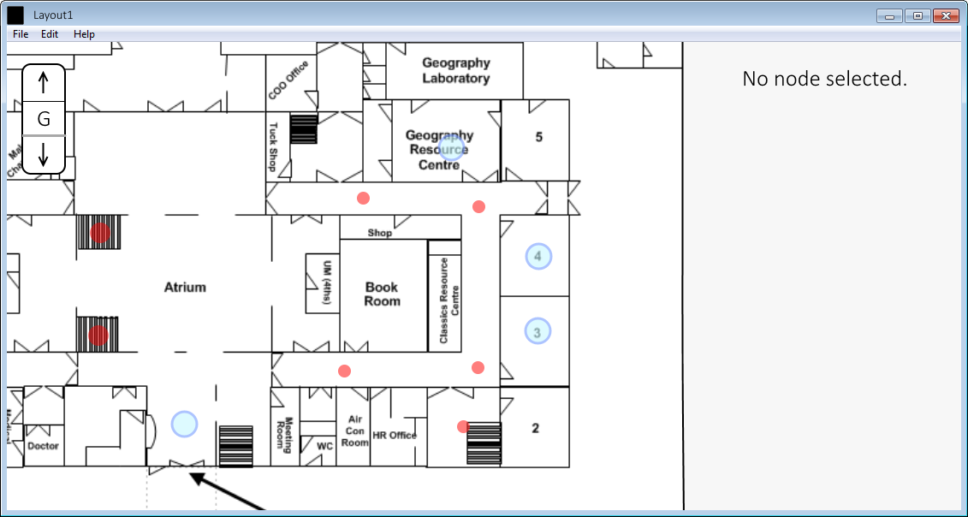

The General Editing state is similar to the Launch Page, but features two panels; the layout view on the left, showing the floor plan and attached nodes of the current floor (floors can be changed with the selector in the top-right of the window) (this panel can be panned and zoomed to move and change the display of the floor), and the node panel on the right. By default, no node is selected, and no node is displayed in the right panel.

* Upon clicking an area on the layout not covered by a circular node while the CTRL key is held (i.e. CTRL + MOUSE1), an ‘invisible’ node is created at that location (symbolized by a red circular node on the layout), which do not serve as viewable rooms but can be used as nodes in path generation. The **Node Editing** display is then shown with that node selected (albeit without details on the right, as the node is not a room).
* Upon clicking an area on the layout not covered by a circular node while the SHIFT key is held (i.e. SHIFT + MOUSE1), a ‘visible’ node is created at that location (symbolised by a light blue circular node on the layout), and the **Node Editing** display is then shown with that node selected.
* Upon clicking a circular node of either colour, the **Node Editing** display is shown with that node selected.
* Upon clicking the up-arrow or down-arrow on the top-right selector element, the floor of the layout shown on the layout view panel changes to the one above or below, respectively. If there is no floor above/below, the button is greyed out and cannot be clicked.

2.1.3 Node Editing

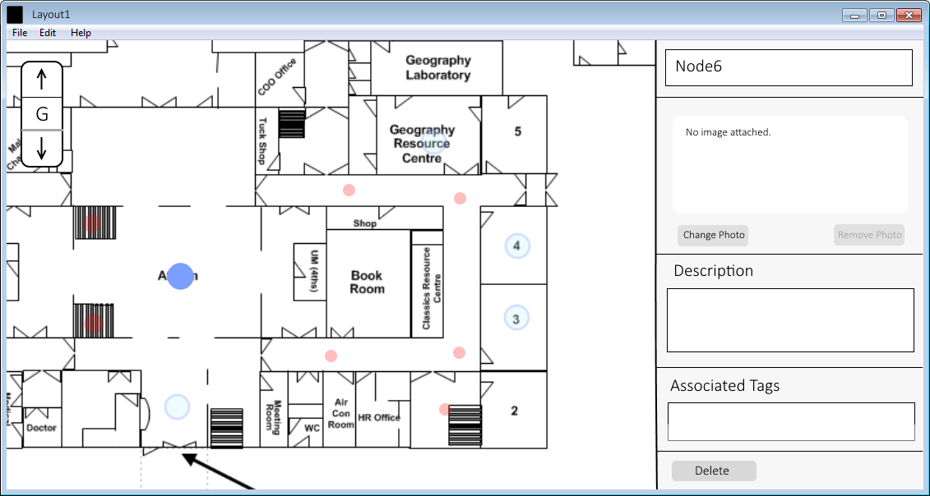

The Node Editing view is the same as the General Editing view, except the selected node becomes solid colour and other nodes become more translucent (as shown above), and details of the node selected appear in the node panel on the right. The node panel on the right features text boxes for the Name, Description, and Associated Tags of each node, as well as a selector for the image file (in PNG format) associated with that node. A delete button is also present that, when selected, deletes the current node and associated data.

* Upon selecting the ‘Change Photo’ button, a popup Windows Explorer window appears, for selection of the image to be associated. The ‘Remove Photo’ button removes this image association.
* Upon selecting a node other than the one currently selected while the CTRL key is held (i.e. CTRL + MOUSE1), a connection is formed between the two nodes, signifying an edge between the two nodes; this is represented as a green line (see below image). Clicking the node again removes the edge between the two nodes.
* Upon clicking the currently selected (solid colour) node, node metadata is saved and the application transitions back to the **General Editing** state.

